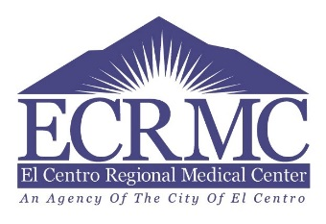
El Centro Regional Medical Center:
Multidisciplinary Research Council
Clinical Trial Project Proposal Requirements
Title Page:
- Project Title
- Principal Investigators (Name, credentials, position/department)
  - CV must be attached to proposal
- Team Members and Sub-PI if applicable
  - Names, credentials, position/department, study role
  - All CV/ Resumes must be attached to proposal
- Date Of Submission
Proposal
- Project Title
- Statement of Purpose and Background
  - Concise description of the problem warranting the study and significance of the problem
  - Benefit for ECRMC participation in Clinical trial
  - Research question(s) &/or hypothesis if applicable
  - Indicate if ECRMC will be Primary Site or Sub-site to another organization
- Protocol Description
  - Study Design and Study Phase
  - IRB specify if study will utilize Central or another organizations IRB
  - Sample
    - Target sample, including inclusion & exclusion criteria
    - Sampling method
  - Recruitment and consent process and procedures
  - Resources require i.e. Pharmacy, imaging, physical space
  - Data Collection
    - Method
    - Instruments, with evidence of reliability and validity for each
    - Attach all study instruments
    - Time line, include end points
- Analysis Plan
- Budget
  - Attach proposed budget
  - If no budget available, include disclosure of direct and indirect costs/ disbursements

